Lab Assignment 9

Memory-Mapped I/O and Object-Oriented Programming

Zhenming Yang, Connor McEleney

[yang.zhenm@northeastern.edu](mailto:yang.zhenm@northeastern.edu), [mceleney.c@northeastern.edu](mailto:mceleney.c@northeastern.edu)

Instructor: Prof. Zagieboylo

[d.zagieboylo@northeastern.edu](mailto:d.zagieboylo@northeastern.edu)

Due Date: November 16th, 2023

Submit Date: November 16th, 2023

**Abstract**

In this lab, we created a c++ program that controls the LED based on user input through the switches and the pushbutton on the DE1SoC board. The program is able to interface with the switches, LEDs and pushbutton to work like a user-controlled button, display binary numbers through the board LEDs. At last, we implemented the control system as C++ objects.

# Introduction

In this laboratory session, we present the idea of utilizing memory-mapped I/O for interacting with devices present on the DE1-SoC, such as LEDs, switches, and push buttons. Beginning with a basic program outlined in this lab manual, which manages the LED states, we will examine the status of additional input devices and establish a collaborative interaction among them. Ultimately, we will employ object-oriented programming to encapsulate and modularize certain aspects of the memory mapped I/O functionality by creating a C++ class.

# Lab Setup

## Pre-Lab

The Pre-Lab for this Lab consisted of writing the RegisterRead() and RegisterWrite() functions as displayed and implemented below, and the keyword volatile means the variable can change at any time without any instruction to.

## Equipment

DE1-SoC:

* The DE1-SoC is a hardware design platform built around the Altera System-on-Chip (SoC) FPGA. The DE1-SoC is designed for experiments on computer organization and embedded systems. It includes embedded processors, memory, audio and video devices, and some simple I/O peripherals.

# Results and Analysis

**Results**

## Part 1: Interfacing with the LEDs and Switches

Based on the prelab functions we created for controlling all LEDs and read the data from all switches using RegisterRead() and RegisterWrite(), we created a new function called ControlLED() which first read all the switch input and then write it to the LEDs (Figure 1).

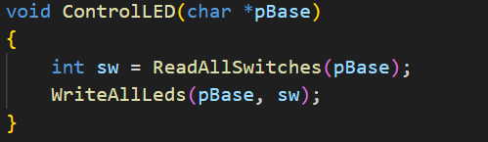

**Figure 1**: The ControlLED() function read the switch position and write it to the leds.

We tested our code on the board, and it gives us the correct respond (Figure 2).

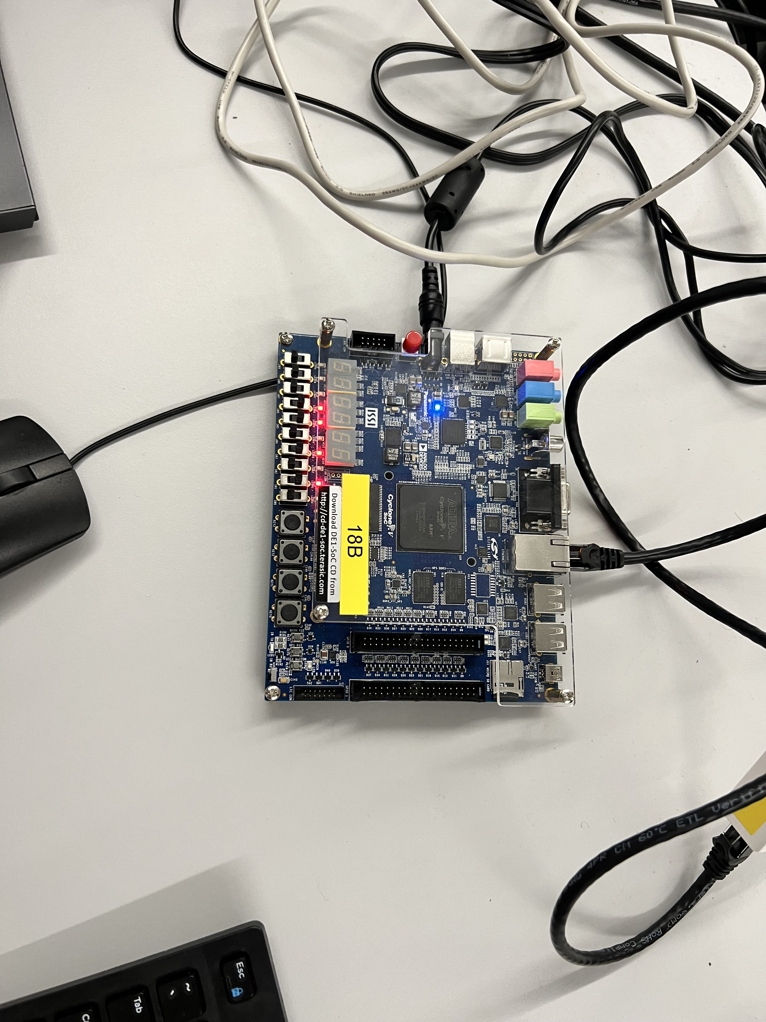

**Figure 2**: The LEDs light up at the correct position where the switches are on.

Our next goal is to write a function that controls a specific LED by turning it on or off. To achieve this, we first read the existing LEDs and get the binary number. We then mask it with the 0x3ff like what we did with the ReadAllSwitches() function and get the correct masked binary. The binary is then modified at the ledNum position by shifting the number 1 to the ledNum position and do the “&” and ~ operation. This will reset the position ledNum to 0. Then the whole thing is “|” with the “state” (which is 1 or 0 in our chase) and shift it to the ledNum to set that specific ledNum to our desired state (Figure 3).

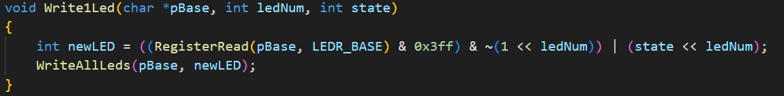

**Figure 3**: The Write1Led function takes the ledNum and the desired stat and modify that position led to our desired state.

We then write a function that read the state of only one switch and return the value. We used the ReadAllSwitches() function to read the value of all switches, shifts them to the desired switchNum, and then “&” with 1 to mask everything else (Figure 4).

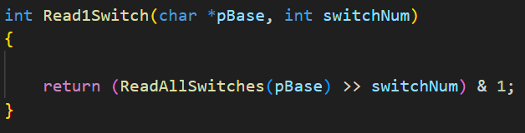

**Figure 4**: The Read1Switch function returns the value of a specific switch.

We tested the Write1Led and Read1Switch functions through the main function and they all returned desirable results (Figure 5-7).

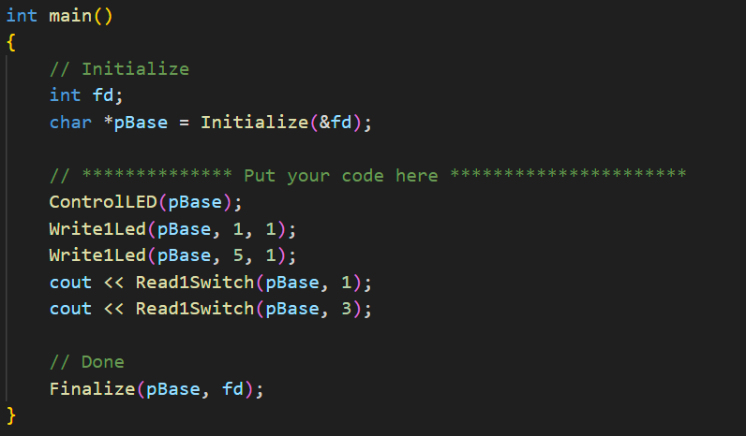

**Figure 5**: The main function we used to test out our functions. The first Controlled function reads all switches and write them on the switches. The Write1Led functions turned on LED1 and LED5. The Read1Switchfunctions read the switched at position 1 and 3 and on the terminal.

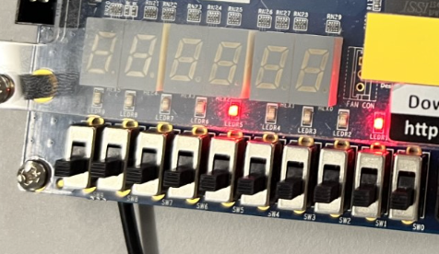

**Figure 6**: The Correct LEDs are turned on through the Write1Led function (LED1, and LED5).

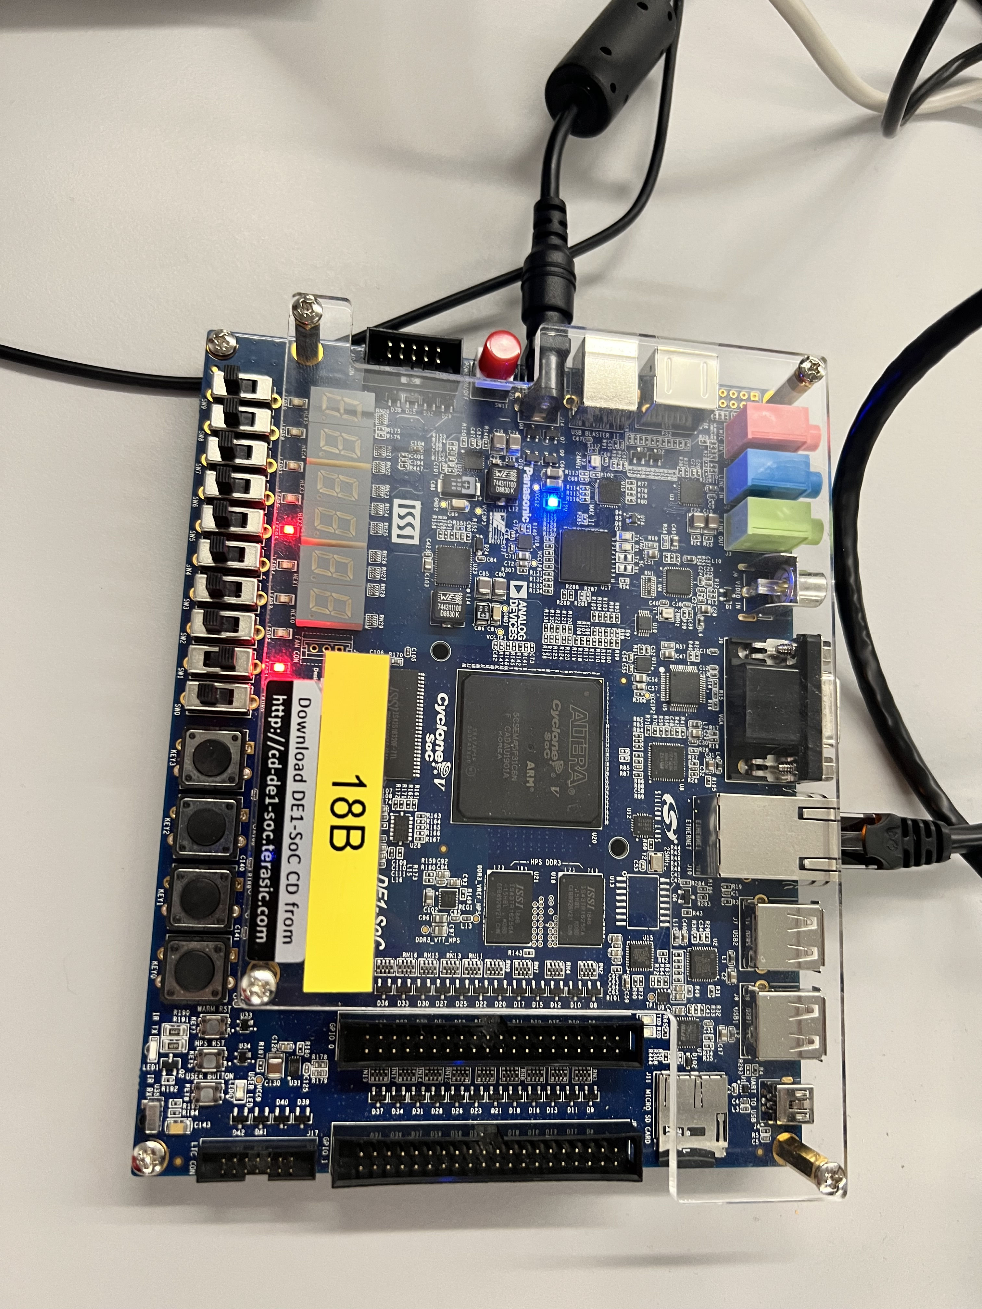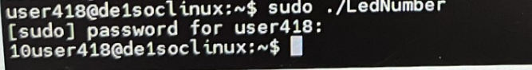

**Figure 7**: The correct read out of the switch value at position 1 and 3. (one and off, 1 and 0).

## Part 2: Interfacing with the Push Buttons

For this part of the lab, we are tasked to develop a program that interprets the present switch configuration as the initial setting for a counter. The program initiates by projecting this counter value onto the LEDs, utilizing functions previously established in prior assignments. Upon pressing the KEY0 button, the program should increment the current counter value by 1, and this modification should be promptly reflected on the LEDs. Consequently, the LEDs consistently showcase the current binary state of the counter. Upon pressing the KEY1 button, the counter should decrease by one. Activation of the KEY2 button should prompt a rightward shift of the current count by one bit position, introducing a 0 on the left side (e.g., 00010111 → 00001011). Similarly, pressing the KEY3 button should lead to a leftward shift of the current count by one bit position, appending a 0 on the right side (e.g., 00010111 → 00101110). Lastly, if multiple buttons are pressed simultaneously, the counter should reset to the value specified by the switches.

To achieve these functionalities, we first creates a function that reads the value of the pushbuttons. The PushButtonGet function first reads the value of the pushbuttons using RegisterRead. And then that value is compared to integer 1, 2, 4, and 8 to see if any of the buttons are pressed (since, binary of 1 is 1 at position 1, binary of 2 is 1 at position 2, 4 is at position 3, and 8 is position 4). If the number is equal to 0 that means, there are no buttons pressed. Otherwise, there are multiple buttons pressed and it should trigger to reset (Figure 8).

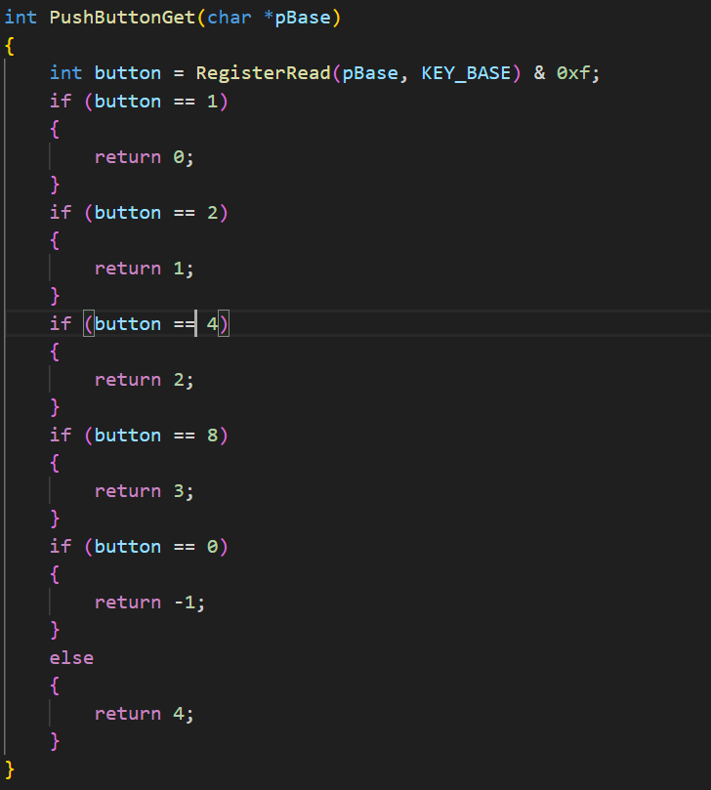

**Figure 8**: The PushButtonGet function returns -1 if no push button is pressed, and a value between 0 and 3 identifying the push button pressed. If multiple push buttons (any two or more) are pressed it should return a value of 4.

To help us test the board better, we run a while loop to keep looking at the reading of the pushbuttons. If there is a change the board will trigger the specific functions: 0 for incrementing by 1 (we do that by simply add 1 to the base), 1 for decrementing by 1 (same as incrementing), 2 for shifting to the right (bit shift 1 to the left), 3 for shifting to the left (same as shifting to right), and 4 is reading the switch position and write it to the LEDs (call the ControlLED function) (Figure 9).

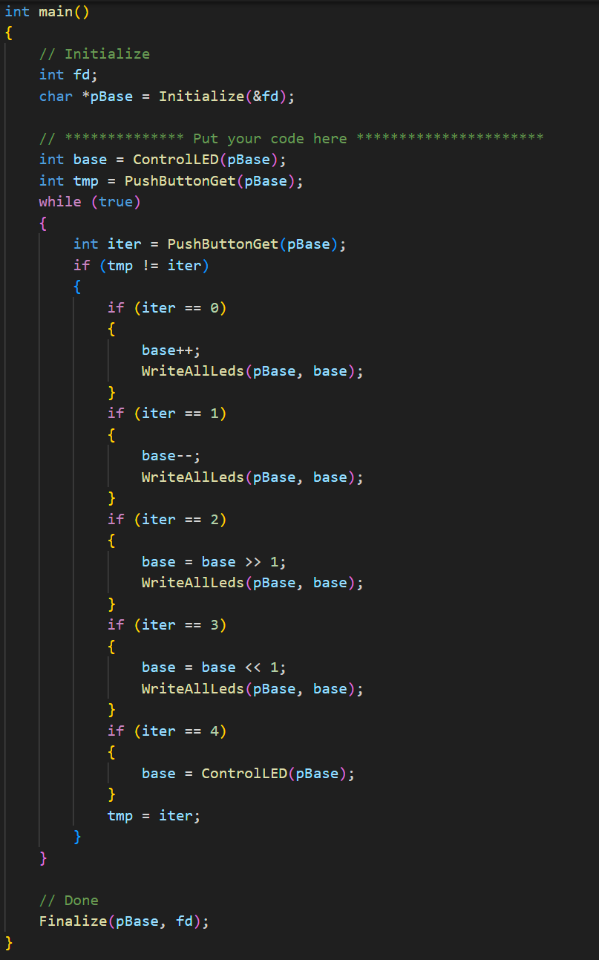

**Figure 9**: Part of main function that loop and look for changes in the pushbutton and trigger the command.

We then tested the functionalities of the pushbutton and the counter and recorded a video to show case our program.

## Part 3: Using C++ objects

In the final section of that laboratory session, we employed object-oriented programming to encapsulate the operations associated with input/output (I/O) on the DE1-SoC. This included abstracting functions such as the initialization and finalization of I/O memory maps, as well as reading or writing operations on I/O memory locations.

We first created the DE1SoCfpga class that initialize the board and memory map the I/O for RegisterRead and Write functions (Figure 10).

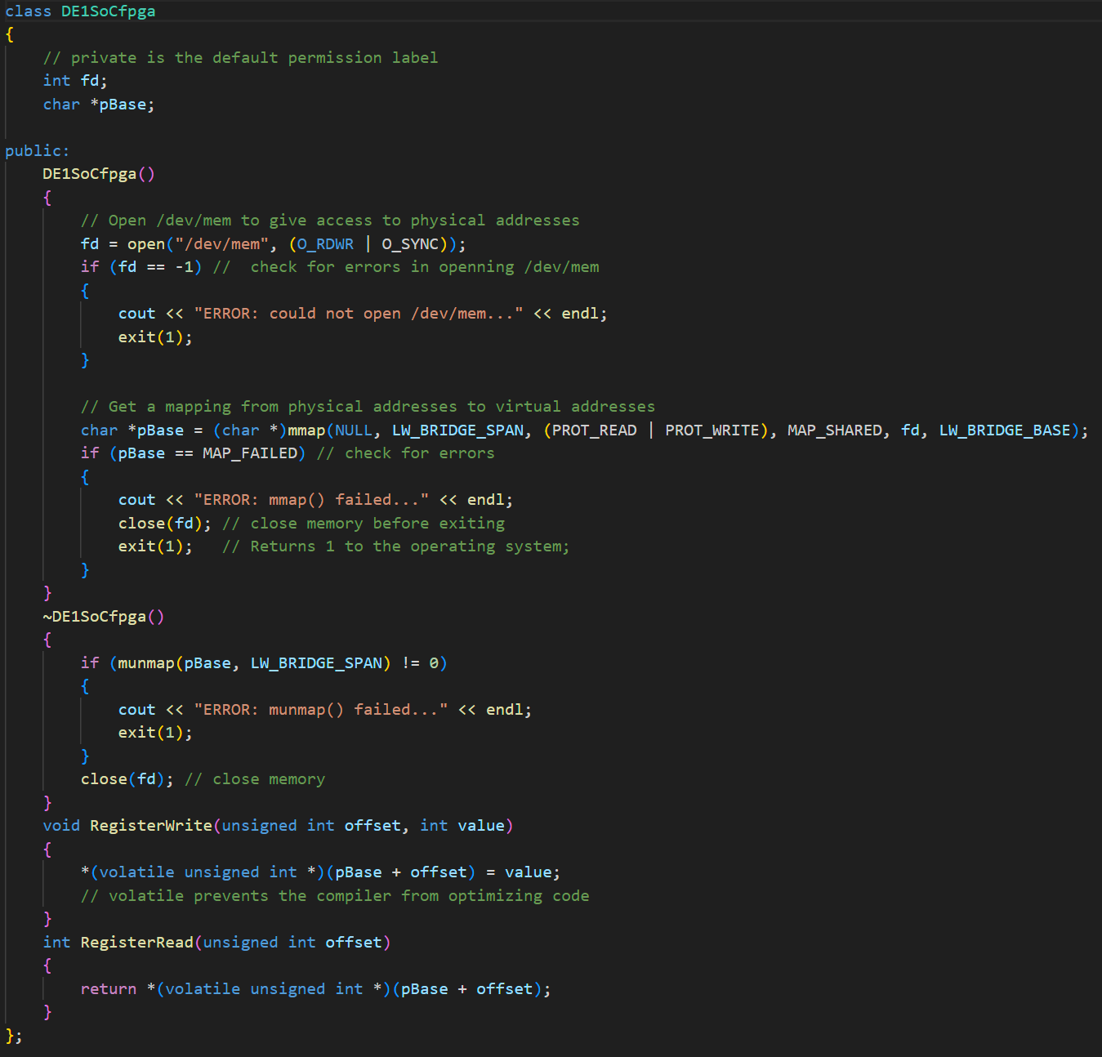

**Figure 10**: The DE1SoCfpga class abstract all the memory mapping and reading from the I/O devices.

The LEDControl class is a child class that inherit the DE1SoCfpga class and have all the functions we had that was needed to control the board to behave like a counter (Figure 11). The classes is tested with the new main function that initializes the LEDControl and works as the functions implementations.

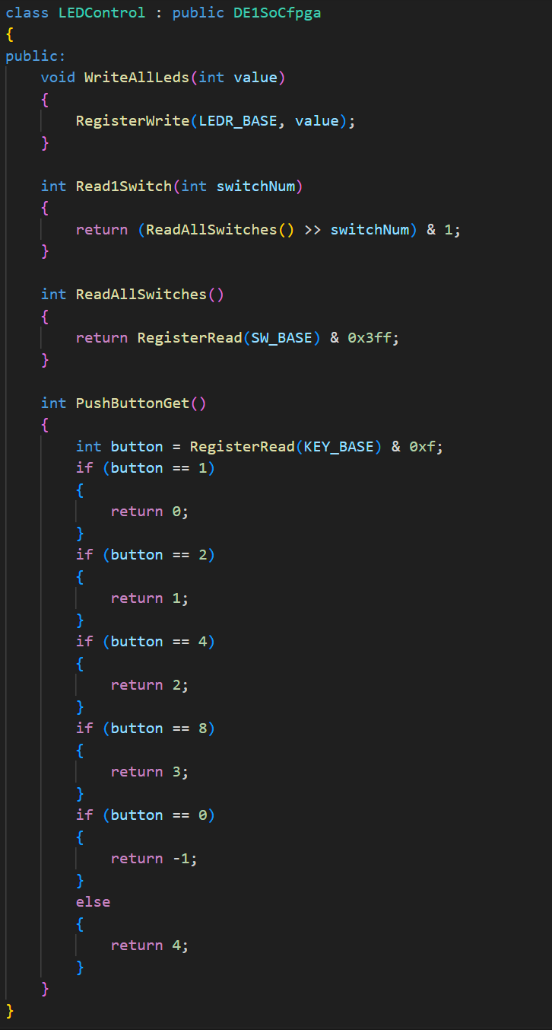

**Figure 11**: The LEDControl class includes all the functions we had in the functional implementations.

**Analysis**

This code implements a DE1SoCfgpa class provided to us to control the interfacing between the hardware and our computers. This class includes functionality to read and write to the boards registers. Using specific bitwise operations specific LED addresses are accessed based on a given functionality we aim to perform. The input is read from both the switches and pushbuttons. For the pushbutton implementation a while loop was used that would constantly call a function that returns the button that was pushed and selects the appropriate function in response, which was used to set and count using the LED’s. We initially had confusion implementing this while loop because we were unnecessarily reading the input three times which caused some delay and sometimes the signal was not picked up.

# Conclusion

In this lab we explored memory mapped I/O with the DE1SoC, taking input from the switches and buttons and outputting data to the LED’s. We integrated memory addressing to target the specific registers of the data we wanted to read/write from. Concepts of object-oriented programming such as inheritance were implemented in the form of the boards parent class and the LEDControl child class.